Your team wants to use an application called fluentd to transform log output from containers into a standard format. In order to make use of this technology, they have asked you to design a proof-of-concept to demonstrate how this can be done. You will need to run a container that generates some log output in a file, then run a second container with fluentd that is able to read the log output from the first container, transform it, and output the transformed data to another file on the host machine. You do not need to have knowledge of fluentd to complete this task. A fluentd configuration file has already been provided for you.

The proof-of-concept should meet the following specifications:

1. The first container should be called counter. It will generate some log data for testing by counting numbers.

For the counter container, use the busybox image with the following command: sh -c 'i=0; while true; do echo "$i: $(date)" >> /var/log/test/1.log; i=$((i+1)); sleep 1; done'. This will write some test data to /var/log/test/1.log every second.

FROM busybox

CMD sh -c 'i=0; while true; do echo "$i: $(date)" >> /var/log/test/1.log; i=$((i+1)); sleep 1; done'

docker build -t busybox:new .

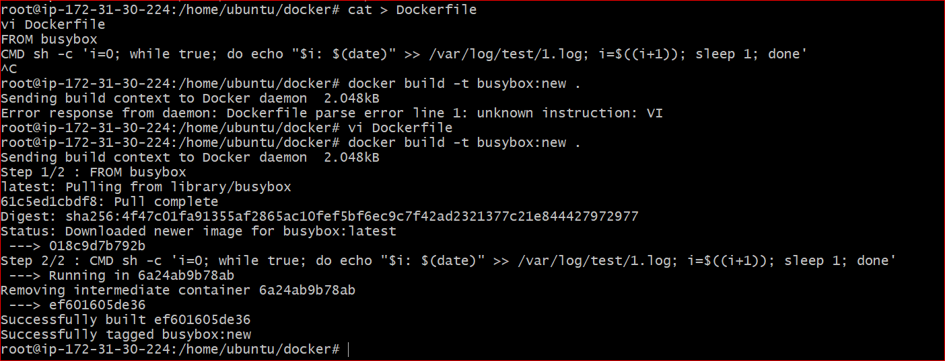

2. Create a volume called test-data, and mount it to the counter container at /var/log/test. This volume will be shared with the fluentd container so that it can read the test data.

ans:-

docker volume create test-data

docker run -d --name counter -v test-data:/var/log/test busybox:new

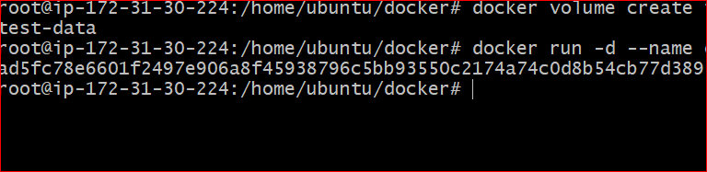

3. Create a second container called fluentd with the k8s.gcr.io/fluentd-gcp:1.30 image.

docker pull fluent/k8s.gcr.io/fluentd-gcp:1.30 image.

4. Provide an environment variable to the fluentd container called FLUENTD_ARGS with the value -c /fluentd/etc/fluent.conf

5. Mount the test-data volume to the fluentd container at /var/log/input.

6. There is a fluentd configuration file located on the server at /etc/fluentd/fluent.conf. Use a bind mount to mount this file to the fluentd container at /fluentd/etc/fluent.conf.

7. Create an additional bind mount so that the fluentd container can output the transformed log data to the host's file system. Mount the directory /etc/fluentd/output on the host to /var/log/output on the fluentd container

docker run -d --name fluentd \

-e FLUENTD_ARGS'-c /fluentd/etc/fluent.conf'\

-v test-data:/var/log/input \

-v /root/fluent.conf:/fluentd/etc/fluent.conf \

-v /root/output:/var/log/output \

k8s.gcr.io/fluentd-gcp:1.30